Color Sorting

Task: You have a friend that is color blind who wants help sorting Lego bricks by color. Using the Lego Spike Essential kit, make a device that helps the friend sort bricks by color.

What are the options? Will it satisfy the design goals?

The hub can measure roll, pitch and yaw angles. Does that help solve the problem? How?

The hub can detect shaking, dropping or tapping. Does that help solve the problem? How?

The hub can display information via the power LED using timed flashes and colors. Can this help solve the problem? How?

The hub can connect to up to two other decides (see below). Can this help with the problem? How?

A color sensor can detect the basic colors of Lego bricks. Can this help solve the problem? How?

The LED matrix can display information with colored LEDs, patterns, and timed flashes. Can this help with the problem? How?

The motor can turn in various ways, round and round, back and forth,and to specific positions. Can this help with the problem? How?

Lego programs can be augmented with sound. Can sounds help solve the problem? How?

How would you solve the problem using Lego Spike Essential kits?

Hint:
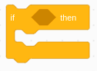
Conditional statements which is a way that computers make decisions based on some "condition," may help solve the problem. A condition may be many things, like is it cold, is this number equal to another number, Is the sensor on, etc. So it could be used to do different actions for different colors when a color sensor is used. If color is red, indicate a red block. If color is blue, indicate a blue block....

To prepare for programming. Turn on the host (Mac, iPad, PC), find the Spike App and start it.

When the app starts, select Spike Essentials on the left side of the window.
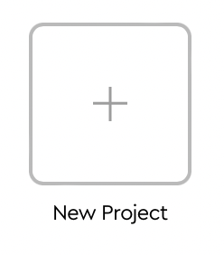
From the center portion the window, select the new project box.

Give the project a name, say “Rock-Paper-Scissors”.

Select word blocks.

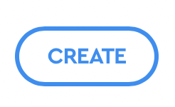
Click on the create button to open the programming window.

Press the Connect button in upper left and follow instructions to connect BlueTooth to the hub.

